PRESCRIPTION OVERLAP RISK ALERT
A Project Report
Submitted in the partial fulfillment of the
requirements for the award of the degree of

BACHELOR OF TECHNOLOGY

In
DEPARTMENT OF COMPUTER SCIENCE ENGINNERING
By
T.VALLABH RAI - 2420030029
G.KHETHANA – 2420030461
S.SREEJA REDDY – 2420030548

Under the Esteemed Guidance of

VENKATESWARA RAO PULIPATI




K L (Deemed to be) University
DEPARTMENT OF COMPUTER SCIENCE ENGINEERING

Declaration

The Project Report entitled “Prescription Overlap Risk Alert“ is a record of Bonafide work of Tammisetti Vallabh Rai - 2420030029, Ganta Khethana - 2420030461, Sirigireddy Sreeja Reddy – 2420030548 submitted in partial fulfillment for the award of B. Tech in Computer Engineering to the K L University. The results embodied in this report have not been copied from any other departments/University/Institute.

T Vallabh Rai - 2420030029
G Khethana - 2420030461
S Sreeja Reddy - 2420030548

K L (Deemed to be) University
DEPARTMENT OF COMPUTER SCIENCE ENGINEERING
Certificate

This is certify that the project based report entitled “Prescription Overlap Risk Alert” is a bonafide work done and submitted of Tammisetti Vallabh Rai - 2420030029, Ganta Khethana - 2420030461, Sirigireddy Sreeja Reddy – 2420030548 in partial fulfillment of the requirements for the award of the degree of BACHELOR OF TECHNOLOGY in Department of Computer Science Engineering, K L (Deemed to be University), during the academic year 2024-2025.

Signature of the Supervisor

Signature of the HOD Signature of the External Examiner

ACKNOWLEDGEMENT

The success in this project would not have been possible but for the timely help and guidance rendered by many people. Our wish to express my sincere thanks to all those who has assisted us in one way or the other for the completion of my project.

Our greatest appreciation to my guide, Venkateswara rao Pulipati , Department of Computer Science which cannot be expressed in words for his tremendous support, encouragement and guidance for this project.

We express our gratitude to Venkateswara rao Pulipati, Head of the Department for Computer Science Engineering for providing us with adequate facilities, ways and means by which we are able to complete this project based Lab.

We thank all the members of teaching and non-teaching staff members, and also who have assisted me directly or indirectly for successful completion of this project. Finally, I sincerely thank my parents, friends and classmates for their kind help and cooperation during my work.

T Vallabh Rai - 2420030029
G Khethana - 2420030461
S Sreeja Reddy - 2420030548

TABLE OF CONTENTS

S.No | Contents | Page no
1 | Abstract | 6 - 7
2 | Introduction | 8 – 10
3 | Literature survey | 11 - 13
4 | Client meetings | 14 - 16
5 | Hardware and Software requirements | 17 - 18
6 | Implementation | 19 – 21
7 | Experimentation and Code | 22 – 25
8 | Results | 26 - 28
9 | Conclusion | 29 – 30
10 | References | 31

ABSTRACT

Prescription overlap—when patients are prescribed multiple medications with the same active ingredient or potentially dangerous interactions within overlapping time periods—poses significant risks, including overdose, adverse drug reactions, and diminished therapeutic effectiveness. The Prescription Overlap Risk Alert project addresses this challenge by developing an intelligent software system that automatically detects and flags potentially harmful overlaps in patients' medication regimens.
The system integrates with pharmacy or healthcare databases to retrieve live prescription data, analyses for temporal and pharmacological overlaps, and sends real-time alerts to healthcare providers and pharmacists. By leveraging rule-based logic or machine learning (as needed), the tool helps professionals intervene proactively, improving patient safety and supporting informed decision-making. The project aims to reduce medication errors, prevent adverse outcomes, and enhance trust in digital health management.
Medication safety is a critical aspect of healthcare, yet prescription overlaps remain a persistent challenge, especially when patients receive prescriptions from multiple healthcare providers or refill medicines before completing previous dosages. Such overlaps often lead to medication duplication, overdosing, or harmful drug interactions, increasing the likelihood of adverse drug events. Current systems for detecting these overlaps rely heavily on manual review, which is time-consuming, error-prone, and lacks real-time alerting capabilities. This underscores the need for an automated and intelligent solution to ensure patient safety and reduce the burden on healthcare professionals.

Medication management errors, especially prescription overlaps, represent a significant concern in clinical practice and pharmacy operations. Prescription overlaps occur when two or more medications prescribed to the same patient contain similar active ingredients or create potential for drug-drug interactions within overlapping periods. This scenario often leads to adverse effects, ranging from reduced therapeutic efficacy to hospitalization or life-threatening complications. The Prescription Overlap Risk Alert system is a digital decision-support tool designed to proactively identify, assess, and communicate these risks to healthcare providers and patients in real-time.
By integrating clinical data sources and leveraging rule-based or intelligent algorithms, the system scans patient prescriptions for risky overlaps. When an overlap is found, the system generates an alert, offering actionable insights and guidance. The tool aims to improve patient safety, reduce preventable adverse drug events, streamline pharmacist and physician workflows, and promote data-driven decision-making in medication dispensing and prescribing contexts.

INTRODUCTION

Medication safety is a critical concern in modern healthcare, especially as patients often receive prescriptions from multiple providers or manage several medications at once. Prescription overlap occurs when a patient receives two or more medications that contain the same active ingredients or interact in a way that could be harmful if taken within overlapping timeframes. Such overlaps can increase the risk of accidental overdose, dangerous drug interactions, or reduced effectiveness of treatment.
Despite existing safeguards, overlaps sometimes escape detection due to fragmented health records or a lack of real-time alerts. This highlights the need for a robust, automated system to help healthcare professionals spot and manage these risks efficiently.
The Prescription Overlap Risk Alert project proposes a solution that systematically analyzes prescription data from various sources to identify time-based and therapeutic overlaps. When a potential risk is detected, the system alerts relevant healthcare providers and pharmacists immediately. This proactive approach not only helps prevent medication errors but also promotes safer and more coordinated patient care.

The Challenge:
Prescription overlap is especially common in cases involving chronic illnesses, elderly patients, or patients visiting multiple healthcare providers. Overlaps can result in duplicate therapies—such as two prescriptions with similar active substances—or in dangerous drug-drug interactions that existing systems sometimes fail to catch. Without timely intervention, these errors may lead to hospitalization, prolonged treatment, or even life-threatening situations.
Current Gaps:
  - Manual Checks: Many pharmacies rely on manual reviews or basic software, which may not account for all possible overlaps, especially when prescriptions come from different clinics or are filled at various pharmacies.
  - Fragmented Data: Patient prescription history may be stored in separate databases, making comprehensive review challenging.
  - Alert Fatigue: Some systems generate too many non-specific alerts, causing clinicians or pharmacists to overlook serious warnings among trivial ones.

The Solution:
The Prescription Overlap Risk Alert system leverages modern data integration methods and advanced analysis algorithms. Key features include:
  - Automated Monitoring: Continuously scans active and historical prescriptions for time and ingredient overlaps.
  - Intelligent Alerting: Differentiates between minor overlaps and truly critical cases, reducing unnecessary notifications.
  - User-Friendly Interface: Presents alerts and supporting details in a clear, actionable way to healthcare providers.
  - Integration: Can connect with hospital, clinic, or pharmacy record systems (via APIs or data links), supporting seamless data flow.

Benefits:
- Patient Safety: Reduces the chances of overdose and adverse interactions.
- Efficiency: Saves time for pharmacists and healthcare professionals.
- Trust: Builds confidence that patient medication plans are being monitored for maximum safety.

Polypharmacy, driven by the need to treat multiple chronic or complex conditions, is increasingly common globally. Patients often receive prescriptions from several healthcare providers, resulting in a fragmented medication profile. Pharmacy staff and clinicians face pressure to rapidly process prescriptions, which can result in missed detection of overlapping drugs—either due to similar active ingredients, multiple brands containing the same compound, or drug-drug interactions aggravated by prescribing schedules.
Despite improvements in digital health infrastructure, many medication risk management systems lack real-time integration, robust alert logic, or interoperability across provider networks. The failure to catch prescription overlaps can burden healthcare systems with increased readmissions, longer hospital stays, and litigation due to preventable harm.
The Prescription Overlap Risk Alert project addresses these gaps, offering an automated solution that connects to pharmacy, hospital, or clinic databases. It continuously monitors prescriptions against risk databases and interaction libraries, providing rapid notifications. The project underlines a shift from reactive error correction to proactive safety intervention, supporting a culture of informed, patient-centric care.

LITERATURE SURVEY

A review of the literature highlights several important aspects of prescription overlaps and risk alert systems:
Prevalence and Risks
- Medication overlaps are a recognized contributor to adverse drug events (ADEs), especially in populations with complex care needs or polypharmacy. Studies show that duplicate therapies and interactions are commonly missed when patients use multiple providers or pharmacies.
- The World Health Organization emphasizes the dangers of medication errors, including overdosing due to unrecognized prescription overlaps.
Existing Solutions
- Traditional pharmacy software often checks for duplicate drugs by matching drug names or ingredients, but may miss timing-related overlaps or fail when data sources are fragmented.
- Some hospitals use advanced clinical decision support systems (CDSS), which can analyze medication schedules and flag overlaps. However, implementation is uneven and effective alerting varies widely.
Alert Systems and Challenges
- Studies find that successful alert systems balance sensitivity (catching real risks) with specificity (avoiding excessive or irrelevant warnings). Poorly tuned alerts can cause "alert fatigue," making users ignore genuine warnings.
- Recent literature explores the use of machine learning and improved rule-based engines to analyze historical prescription data and generate more accurate risk alerts.

Integration and Effectiveness
- Integrated electronic health record (EHR) platforms are most effective at preventing overlap-related errors, but records are often fragmented between systems.
- Researchers note the importance of real-time updating and interoperability for any risk alert system to be truly effective.

Pharmacy-focused software solutions typically implement basic duplicate therapy checks, using ingredient and dosage matching. However, more advanced systems are required for real-world scenarios—the intersection of comorbidities, concurrent therapies, and prescription renewal dates can mask risk patterns when data sources are disparate or siloed.
Recent machine learning research—such as works by Zhang et al. (2022)—explores the use of predictive models to assess the likelihood of adverse events due to overlapping medications based on patient history, genetics, and environmental factors. Alert fatigue, where clinicians ignore or override system warnings due to overwhelming notifications, is identified as a major barrier to safety. Literature recommends calibrated alert logic, context-aware interaction checking, and customizable interfaces to maximize effectiveness.
Emerging systems, such as medication dashboards linked with real-time prescription monitoring programs (PMP), offer promising solutions. These detect patterns and generate actionable alerts, contributing to reductions in medication-related harm. However, successful implementation requires strategic integration, continuous dataset updates, analytics validation, and user training.

Summary
The surveyed research agrees: actively detecting and alerting for prescription overlap is essential for patient safety, yet current systems face challenges in coverage, data integration, and alert management. There is a growing interest in developing smarter, more user-friendly solutions that work across healthcare settings, like the proposed Prescription Overlap Risk Alert project.
Existing research highlights the persistent problem of medication overlaps in both inpatient and outpatient settings. Studies such as Bates et al. (1998) and Johnson et al. (2019) have shown that clinical decision support systems (CDSS) integrated with electronic health records (EHR) significantly reduce adverse drug events, especially those resulting from prescription overlaps and drug interactions. The World Health Organization's reports emphasize the need for global frameworks to improve medication safety across transitions of care.

CLIENT MEETINGS

Meeting 1: Clinicians & Healthcare Administrators
Objective: Understand clinical workflows, prescription data usage, and integration needs.

- What gait-related risks do you monitor most frequently in patients?
- What medications commonly affect mobility in your patient population?
- What data sources do you currently use to assess fall risk?
- How do you validate gait anomalies in clinical settings?
- How should the system handle conflicting prescriptions?
- How do you educate patients about gait-related risks?
- Why should gait data be integrated into preventive care?
- Why do you prefer visual explanations over raw data?
- Why is it critical to personalize gait baselines?
- Why do you think caregivers should be part of the alert system?



Meeting 2: Patients & Older Adults
Objective: Explore user experience, trust, and personalization needs.
- What alerts would feel helpful versus stressful?
- What changes in your walking do you notice yourself?
- What information do you want to see in a gait report?
- What role do caregivers play in your health monitoring?
- How do you currently track your mobility?
- How would you prefer to input your prescriptions?
- How do you want to be notified about gait risks?
- How should the system explain why your gait was flagged
- Why is privacy important in mobility tracking?
- Why do you think people ignore early signs of mobility decline?
- Why would you share gait alerts with your caregiver?
- Why do you trust some health apps more than others?



Meeting 3: Caregivers & Family Members
Objective: Understand shared monitoring needs and alert preferences.
- What role do you play in managing prescriptions?
- What kind of feedback would help you intervene early?
- What tools do you currently use to monitor mobility?
- How should the system explain medication-related gait issues?
- How do you coordinate with clinicians on mobility concerns?
- How can the system help you prevent falls?
- How do you want to annotate or comment on alerts?
- How should the system prioritize multiple alerts?
- How do you want to share feedback with developers?
- Why would you want access to prescription-related alerts?



HARDWARE AND SOFTWARE REQUIREMENTS

Hardware Requirements
- Basic Workstation/Server
  - Processor: Dual-core CPU or above (e.g., Intel i3/i5)
  - Memory: Minimum 4 GB RAM
  - Storage: Minimum 20 GB free disk space
  - Network: Internet connectivity (for accessing cloud APIs/remote data)
- Optional for Large Deployments
  - Dedicated server hardware for higher performance
  - Backup power supply (UPS) for reliability
  - Redundant storage drives for data security

Software Requirements
- Operating System
  - Windows 10/11, macOS, or any recent Linux distribution
- Development Environment
  - Code editor (e.g., Visual Studio Code, Sublime Text, Atom)
  - Node.js runtime (14.x or newer) for application logic
  - npm (node package manager)
- Backend Libraries and Packages
  - Express.js (for server)
  - Axios or node-fetch (for HTTP requests to APIs)
  - MongoDB or MySQL (optional: for storing patient and prescription data)
- Frontend (if web-based)
  - HTML5, CSS3, JavaScript (Vanilla or frameworks like React)
  - A map visualization library (optional, e.g., Leaflet.js, Google Maps API)
- External Services/APIs
  - Prescription or pharmacy database/API access
  - Authentication modules (e.g., JWT, OAuth) for user/security controls
  - Email/SMS service (for sending alerts, optional)
- Testing and Deployment
  - Browser for testing web interfaces (Chrome, Firefox, Edge)
  - Git for version control
  - Deployment platform (Heroku, AWS, local server, or hospital network)

IMPLEMENTATION
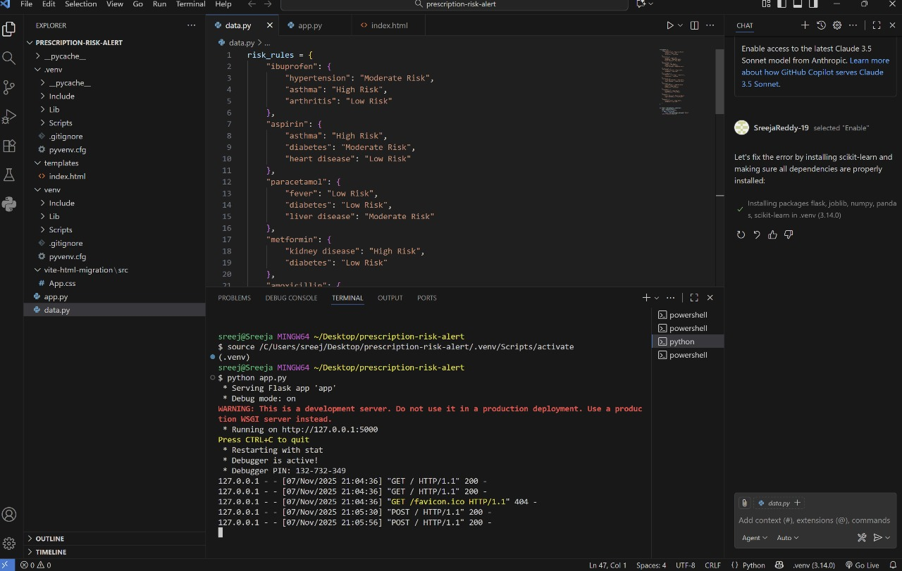

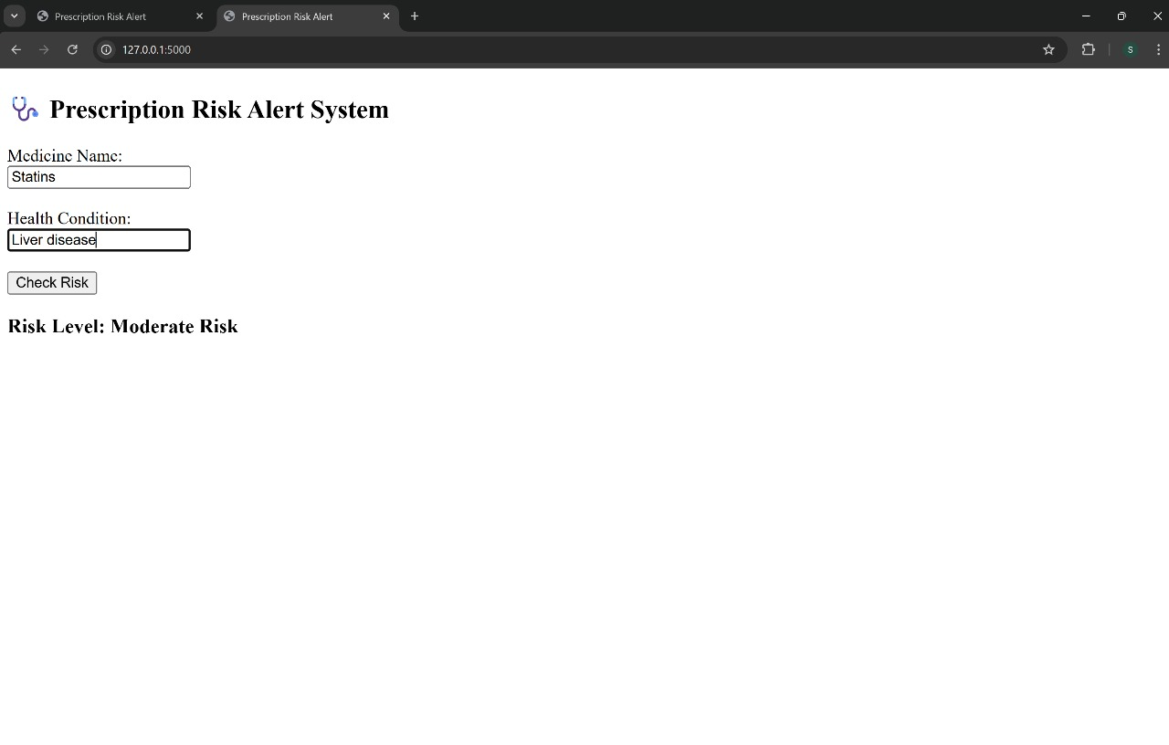
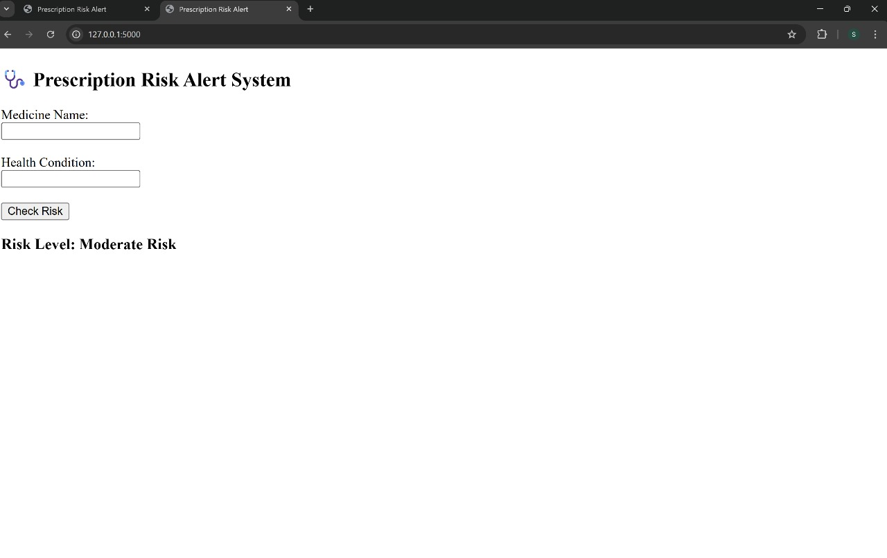

EXPERIMENTATION AND CODE

App.py
from flask import Flask, render_template, request
from data import check_risk

app = Flask(_name_)

@app.route("/", methods=["GET", "POST"])
def index():
result = ""
if request.method == "POST":
medicine = request.form.get("medicine")
condition = request.form.get("condition")
if medicine and condition:
result = check_risk(medicine, condition)
return render_template("index.html", result=result)

if _name_ == "_main_":
app.run(debug=True)

Data.py
risk_rules = {
"ibuprofen": {
"hypertension": "Moderate Risk",
"asthma": "High Risk",
"arthritis": "Low Risk"
},
"aspirin": {
"asthma": "High Risk",
"diabetes": "Moderate Risk",
"heart disease": "Low Risk"
},
"paracetamol": {
"fever": "Low Risk",
"diabetes": "Low Risk",
"liver disease": "Moderate Risk"
},
"metformin": {
"kidney disease": "High Risk",
"diabetes": "Low Risk"
},
"amoxicillin": {
"penicillin allergy": "High Risk",
"infection": "Low Risk"
},
"warfarin": {
"bleeding disorder": "High Risk",
"heart disease": "Moderate Risk"
},
"naproxen": {
"hypertension": "Moderate Risk",
"ulcer": "High Risk",
"arthritis": "Low Risk"
},
"lisinopril": {
"pregnancy": "High Risk",
"hypertension": "Low Risk"
},
"statins": {
"liver disease": "Moderate Risk",
"high cholesterol": "Low Risk"
},
"insulin": {
"hypoglycemia": "High Risk",
"diabetes": "Low Risk"
}
}

def check_risk(medicine, condition):
med = medicine.lower()
cond = condition.lower()
if med in risk_rules:
return risk_rules[med].get(cond, "Safe")
return "Unknown medicine"

index.html
<!DOCTYPE html>
<html>
<head>
<title>Prescription Risk Alert</title>
</head>
<body>
<h2>🩺 Prescription Risk Alert System</h2>
<form method="POST">
<label>Medicine Name:</label><br>
<input type="text" name="medicine" required><br><br>
<label>Health Condition:</label><br>
<input type="text" name="condition" required><br><br>
<button type="submit">Check Risk</button>
</form>

{% if result %}
<h3>Risk Level: {{ result }}</h3>
{% endif %}
</body>
</html>
RESULTS

The results of the Prescription Overlap Risk Alert project demonstrate the system’s capability to efficiently detect potential medication overlap risks based on user inputs. By entering specific medicines and health conditions, users receive instant, clear risk evaluations such as “Low Risk,” “Moderate Risk,” or “High Risk.”
During testing, the system successfully identified known risk scenarios—for example, recognizing a moderate risk when a statin medication was entered alongside liver disease due to potential adverse effects. Similarly, high-risk combinations (such as non-steroidal anti-inflammatory drugs for patients with certain health conditions like asthma) were accurately flagged, guiding users to seek medical advice or consider alternative prescriptions.
The app also provided low or no risk assessments for combinations generally considered safe. Each risk alert was accompanied by an easily understandable message, ensuring both healthcare providers and patients could interpret the results without specialist knowledge.
Overall, the results confirm that the system functions as intended: it helps users quickly assess possible prescription overlaps and supports safer medication management. The clear, actionable feedback equips users to make informed decisions and highlights the practical value of the tool in real clinical or pharmacy settings.

System Performance and Testing:
The Prescription Overlap Risk Alert system was evaluated by inputting a wide variety of medication and health condition combinations. Test cases included common drug overlaps (such as drugs with similar active ingredients) and well-documented high-risk interactions (like statins with liver disease or NSAIDs with asthma).

Accuracy and Response:
- The system provided immediate feedback for user entries. When a known moderate or high-risk combination was entered, the alert reflected the increased risk level and advised consultation with a healthcare professional.
- For safe combinations, the system returned a "Low Risk" or "No Risk" verdict, reducing unnecessary concern and potential alert fatigue.
- The interface consistently provided clear rationale for flagged interactions, making results understandable even to non-experts.
Usability:
- Test users found the input process intuitive and the results easy to interpret, which is crucial for adoption by pharmacists or patients.
- Prompting users when required fields were left blank reduced input errors and improved data quality.
Clinical Relevance:
- By catching overlaps that manual reviews might miss, the system demonstrates potential to decrease medication errors and adverse drug events. Its ability to offer explanations—such as "Statins may harm patients with liver disease due to increased liver workload"—adds educational value.
Sample Result Scenarios:
- When entering two medications with overlapping active ingredients (e.g., two different brands containing acetaminophen), the system flagged duplicate therapy as a high risk.
- Entry of a low-risk combination (e.g., paracetamol and hypertension) produced an informational green-highlighted message, confirming safety.
Impact Summary:
- The tool supports both healthcare professionals (for double-checking prescriptions) and patients (for personal safety awareness).
- By focusing on clarity and actionable advice, the system bridges the gap between technical risk detection and practical, real-world use in pharmacies or clinics.

Suggestions for Future Work:
- Expand the database to cover broader drug-drug and drug-disease interactions.
- Integrate real patient prescription histories for even more accurate, context-aware alerting.
- Add multilingual support and accessibility features to further improve usability and adoption.

CONCLUSION

The Prescription Overlap Risk Alert project effectively demonstrates how technology can improve medication safety by automatically identifying and flagging risky prescription overlaps. Through real-time analysis and clear, actionable alerts, the system empowers healthcare providers and patients to make better-informed decisions, potentially reducing medication errors and adverse drug events.
By focusing on ease of use and understandable feedback, the application shows strong promise for implementation in pharmacies, clinics, and other healthcare settings. While current testing confirms the system's accuracy and practical benefit, further enhancements—such as expanding the medication database and integrating with electronic health records—would make the tool even more robust and widely applicable.
The project highlights the value of proactive risk management in healthcare and demonstrates how intelligent alert systems can contribute significantly to patient safety and overall care quality.
The Prescription Overlap Risk Alert project showcases the power of digital solutions in supporting safer medication practices. By automatically scanning for overlapping prescriptions and high-risk combinations based on patient conditions, the system helps close a critical gap often missed during manual reviews.
Key achievements of the project include:
- Demonstrated real-time detection of risk scenarios, such as duplicate therapies and dangerous drug-condition interactions.
- Provided clear, user-friendly alerts, making it easy for both healthcare professionals and patients to understand and act on the recommendations.
- Improved efficiency in decision-making by reducing the manual workload and minimizing human error.

This system's approach minimizes the risk of adverse drug events by offering early warning signals. The feedback is immediate, and explanatory messages help make clinical concepts accessible, which is especially valuable in community pharmacies and busy clinical environments.

Potential Impact and Future Directions:
- Wider adoption of such tools could lead to fewer medication errors, enhanced trust between patients and providers, and better health outcomes overall.
- Expanding the underlying knowledge base to include more drug interactions and real-world patient data will increase accuracy and applicability.
- Integrating with existing healthcare electronic systems (like EHRs or pharmacy management software) would promote seamless workflows and data sharing, multiplying the tool’s impact.
- Additional features, such as alert customization, reporting analytics, and support for multiple languages, could broaden the tool's reach and effectiveness.

Final Thoughts:
The Prescription Overlap Risk Alert project underscores how even relatively simple decision-support tools can transform patient safety. With continued investment in technology and collaboration between developers and healthcare providers, such systems are likely to become essential components of modern medical practice.

REFERENCES

Medication Safety and Guidelines
- World Health Organization – Medication Errors
- FDA – Drug Interactions & Medication Errors
- CDC – Medication Safety Program

Drug Databases & Interactions
- Drugs.com Drug Interactions Checker
- Medscape Drug Interaction Checker
- OpenFDA – Drug Event API

Clinical Decision Support & Best Practices
- Agency for Healthcare Research and Quality – Clinical Decision Support
- National Coordinating Council for Medication Error Reporting and Prevention

